Unknown B: tert-butyl chloride
Carleigh King
November 28, 2023
CHEM 2081-003
Introduction
The goal of this experiment was to identify an unknown by means of Nuclear Magnetic Resonance (NMR) Spectroscopy, Fourier Transform Infrared (FTIR) Spectroscopy, and Gas Chromatography-Mass Spectrometry (GCMS). These data tables gave adequate data to determine the identity of the unknown compound and the functional groups within it. It is important to have the skill of reading these tables accurately so that molecules can be identified properly. Spectroscopy is important in chemical analysis because it reveals how light is absorbed and emitted by a compound, and it displays various interactions between electrons, protons, and ions along with their interactions with other particles. However, results are not fully determined by spectroscopy. Spectrometry gives the actual measurement of a spectrum. Spectrometry is important in chemical analysis because it measures the interaction of light and matter along with its absorbance.
Body
Nuclear Magnetic Resonance (NMR) Spectroscopy involves the study of the interaction between electromagnetic radiation and the nuclei of atoms. An NMR spectrometer can probe the nucleus of an atom to determine its nuclear spin, which reveals either an odd number of protons or neutrons. A proton brings a rotating charge which creates a magnetic moment which is similar to a magnetic field. NMR spectroscopy uses a magnetic field and a source of radio frequency radiation. The magnetic field allows the nuclei to absorb radio frequency radiation because it creates a gap between spin states. The amount of radio frequency radiation absorbed aids in determining the identity of the unknown. The location, area, and shape of each signal aids in determining an unknown substance. NMR spectroscopy helps determine the number of different kinds of protons in a molecule and how they contribute to each group of signals. This is called integration. The positions of signals on the horizontal axis are called chemical shift, and the patterns within the groups of signals are called spin-spin coupling. By determining if the group is a singlet, doublet, triplet, or quintet (etc.), the structure of a compound can be partially determined. If an atom is connected to a carbon with no other protons attached to it, then it is a singlet. This follows the “n+1” formula. “N” being the number of protons.
Fourier Transform Infrared (FTIR) Spectroscopy irradiates a sample with all frequencies at the same time and mathematically determines the frequencies passed through the sample. An Infrared spectrometer measures percent transmittance, or the absorption spectrum. A frequency unit called “wavenumber” is used to report the location of each signal. Wavenumber is proportional to frequency which means a larger wavenumber represents higher energy. Three characteristics of an IR spectrum are wavenumber, intensity, and shape. Wavenumber is dependent on bond strength and the mass of the atoms involved in bond sharing. FTRI helps in determining functional groups of a compound. Different frequencies found at various wavenumbers indicate the presence of specific functional groups. Intensity of signals give indication to certain functional groups as well. A strong signal is longer, whereas a weak signal is shorter. The shape of a signal varies as well. Some signals are broad, and others are narrow. Alcohols give a broad signal due to hydrogen bonding. This is due to inconsistent bond strengths because of the hydrogen bond not fully participating in bonding with oxygen. Steep signal within the center of the graph indicates C-H bonds. These bonds should be located around 3000 cm-1.
Gas Chromatography-Mass Spectrometry is used to identify the compounds inside of a mixture by separating them from each other and putting them into a mass spectrometer to create various spectra. A gas chromatograph-mass spectrometer is the device used to analyze the compounds within the mixture. The mixture is first separated in the gas chromatograph and analyzed by the mass spectrometer. A gas chromograph contains a long tube containing a boiling liquid on a solid support which is called the stationary phase. The temperature is maintained in an oven. A sample is injected into the gas chromatograph and is vaporized and carried through the tube. Each compound in the mixture has a different affinity for the stationary phase and stays within the tube for a certain time. This is called the retention time. The compounds are separated from each other based of differing retention times. The chromatogram reveals the retention time of each compound in the mixture. The retention time aid in determining what groups are involved in the compound.
NMR Sample B
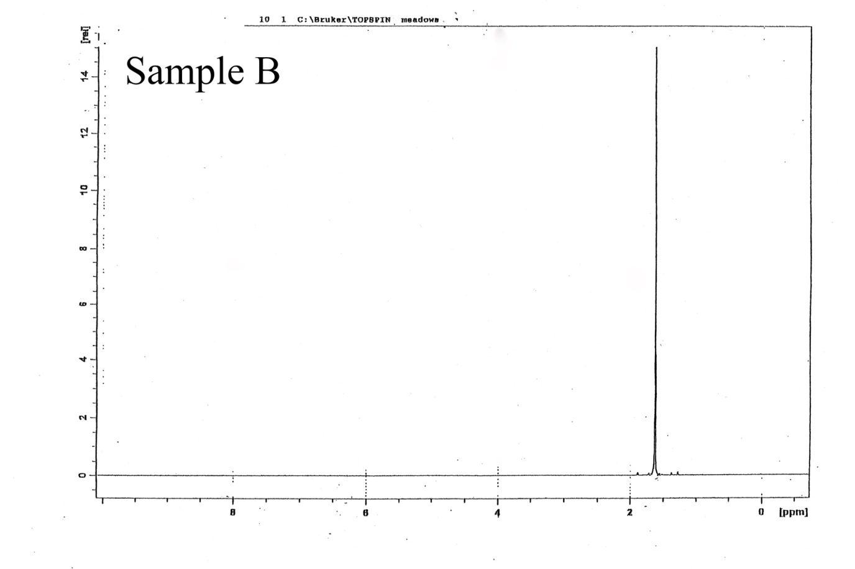

FTIR Sample B
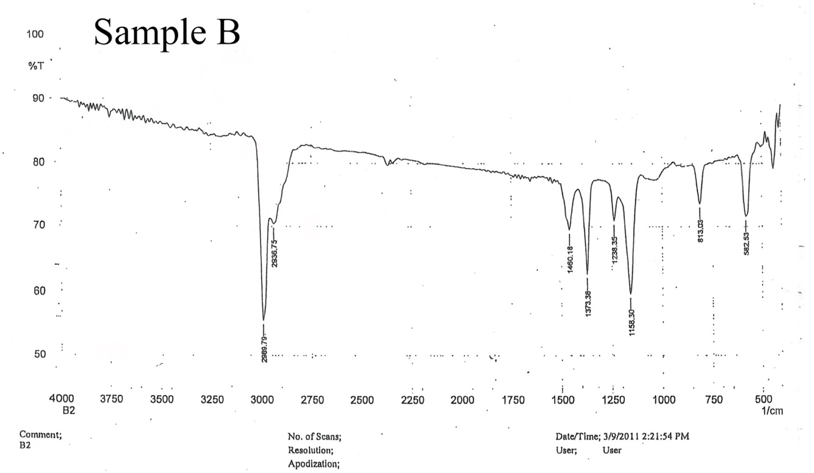
GCMS Sample B
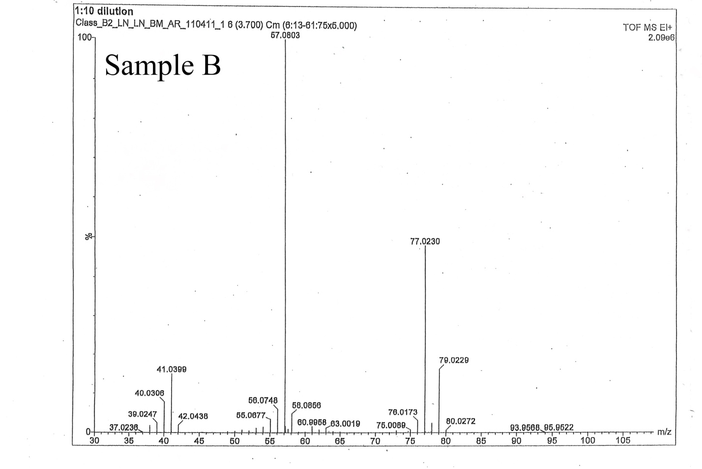

Analysis

For NMR, the big spike reveals that the compound is a singlet, meaning there are no neighboring and adjacent protons. Tert-butyl contains three methyl groups attached to a carbon. The carbon is not attached to another carbon, but an R group instead, because a singlet indicates there is not adjacent proton to the group. The R group is revealed as chloride in the GCMS graph. This big spike is also characteristically indicative of the presence of a tert-butyl group.

For FTIR, it is clear that there are no OH groups in this molecule because there are no dips in the graph at the beginning or in the center in the 1750 region. However, there is a steep dip in the graph that indicates only C-H groups.

For GCMS, looking at the graph on the far right, there is data indicating a chloride group in the molecule. This is due to a tall line followed by a shorter line and then ending with a line that is 1/3 the height of the long line. This is clear indication of a chloride group in the molecule. This graph was also used to find the number of chlorides in the molecule. One of the data numbers on the graph that indicate chloride is 79.0229 m/z. The atomic mass of chlorine is 35.453 amu. Thus, 79.0229 minus 35.453 gave the number 43.570. This number divided by the atomic mass of carbon (12.011 amu) is equal to 3.627, which is rounded to four carbons. This means the molecule contains four carbons which further indicates the molecule to be tert-butyl chloride.

Conclusion

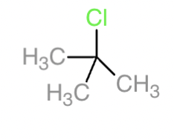
By using the data found in NMR, GCMS, and FTIR, the unknown compound is tert-butyl chloride. The data presented in each of these graphs gave indication that the compound is tert-butyl chloride. By identifying the multiplicity of the compound using NMR, finding only C-H groups present in the FTIR graph, and calculating the number of carbons present using the data on GCMS, the compound was determined to be tert-butyl chloride. The data found in NMR and GCMS were very helpful in determining the length and overall structure of the compound. FTIR was helpful in determining what functional group was not present.

References
H. McNeil. Conversion of Camphene to Camphor. Department of Chemistry, A. U. Chem 2081 Organic Chemistry 1 Lab Manual. Macmillan Learning Curriculum Solution: Plymouth, 2023, (p. 85-174).

